A Project report on

Noise Removal From ECG Signal Based On Filtering Techniques

Submitted in fulfilment of requirements for the award of degree

Bachelor of Technology in Electronics and Communication Engineering

Submitted by

K. Kamal Hanesha O161636

K. Ganapathi O161817

G. Naveen O160793

M. Swetha O161881

V. Jennifer O161724

CH. Poojitha O161333

UNDER THE ESTEEMED GUIDANCE OF

N. Padmavathi

Internal Guide



Department of Electronics and Communication Engineering

RAJIV GANDHI UNIVERSITY OF KNOWLEDGE TECHNOLOGIES

Department of Electronics and Communication Engineering



CERTIFICATE

This is to certify that the mini project entitled ‘NOISE REMOVAL FROM ECG SIGNAL BASED ON FILTERING TECHNIQUES’ is being submitted by K. Kamal Haneesh(O161636),K.Ganapathi(O161817),G.Naveen(O160793),M.Swetha(O161881),V.Jennifer(O161724),CH.Poojitha(O161333)in partial fulfilment of the requirements for the award of BACHELOR OF TECHNOLOGY to RGUKT ONGOLE in ELECTRONICS AND COMMUNICATION ENGINEERING. This record is a bonafide work carried out by them under my guidance and supervision. The results embodied in this report have not been submitted to any other university for the award of any degree.

UNDER THE GUIDANCE HEAD OF DEPARTMENT

Head of Department Internal Guide

Name Name

Department of Electronics and Communication Engineering



DECLARATION

We,K.KamalHaneesh(O161636),K.Ganapathi(O161817),G.Naveen(O160793),M.Swetha(O161881),V.Jennifer(O161724),CH.Poojitha(O161333) hereby declare that the mini project report titled “NOISE REMOVAL FROM ECG SIGNAL BASED ON FILTERING TECHNIQUES” submitted in partial fulfilment of the requirements for

the award of BACHELOR OF TECHNOLOGY in ELECTRONICS AND COMMUNICATION ENGINEERING to Jawaharlal Nehru Technological

University, Hyderabad. Under the guidance of………………………Assistant professor in the Department of Electronics and communication Engineering, Samskruti College of Engineering and Technology. This record is a bonafide work carried out by us. The results embodied in this report have not been submitted to any other university

# 

# ACKNOWLEDGEMENT

We would like to express our gratitude to all the people without whom it would have been difficult to complete this project. we are thankful to all of them for their time and support.

We are extremely intended to our project guide, ………………whose guidance and supervision enabled us to look for different techniques and apply innovative ideas. We are thankful to him for the time and valuable advice he has given us.

We are thankful TO …………………………………..

Electronics and Communication Engineering Dept, Rajiv Gandhi University of Knowledge Technologies, for his support and encouragement. We would also like to thank him for his valuable suggestions.

# ABSTRACT

To find an efficient method for ECG Signal Analysis which is simple and has good accuracy and less computation time. The initial task for efficient analysis is the removal of noise. It actually involves the extraction of the required cardiac components by rejecting the background noise. Enhancement of signal is achieved by the use of Empirical Mode Decomposition method. The use of EMD was inspired by its adaptive nature. The second task is that of R peak detection which is achieved by the use of Continuous Wavelet Transform. Efficiency of the method is measured in terms of detection error rate. Various other methods of R peak detection like Hilbert Transform and Difference Operation Method are implemented and the results when compared with the Continuous Wavelet Transform prove that CWT is a better method. The simulation is done in MATLAB environment. The experiments are carried out on MIT-BIH database. The results show that our proposed method is very effective and an efficient method for fast computation of R peak detection.

Keywords: ECG signal, filtering techniques, MSE, noise removal techniques,EMD.

# 

CONTENTS

ACKNOWLEDGEMENT iv

ABSTRACT v

|  |  |
| --- | --- |
| LIST OF FIGURES | vii |
| LIST OF TABLES | viii |
| CHAPTER 1 INTRODUCTION | 1 |
| 1.1 INTRODUCTION | 1 |
| 1.2 MOTIVATION | 2 |
| 1.3 AIM OF THE PROJECT | 3 |
| 1.4 PROBLEM STATEMENT | 3 |
| 1.5 ORGANISATION OF THE PROJECT | 3 |
| CHAPTER 2 LITERATURE SURVEY | 4 |
| CHAPTER 3 HARDWARE IMPLEMENTATION | 8 |
| 3.1 DATA PROCESSING | 8 |
| 3.2. SYSTEM GENERATOR BLOCKS  3.3. DESIGN 1: THRESHOLD BASED ON PREVIOUSLY | 9 |
| DETECTED PEAK VALUE | 10 |
| 3.4. MEMORY MODULE | 10 |
| 3.5 WINDOW MODULE | 12 |

CHAPTER 4 SOFTWARE IMPLEMENTATION 14

4.1 USE OF HILBERT TRANSFORM FOR R-PEAK DETECTION 14

4.1.1 Hilbert Transform 14

4.1.2 Methodology 15

4.2 USE OF DIFFERENCE OPERATION METHOD FOR R PEAK DETECTION 20

4.2.1 Difference Operation Method 20

4.2.2 Methodology 20

4.3 USE OF CONTINUOUS WAVELET TRANSFORM IN R PEAK DETECTION 24

|  |  |
| --- | --- |
| 4.3.1 Wavelet Transform | 24 |
| 4.3.2 Continuous Wavelet Transform | 24 |
| 4.3.3 Methodology | 26 |

CHAPTER 5 RESULTS 30

|  |  |
| --- | --- |
| CHAPTER 6 CONCLUSION | 32 |
| CHAPTER 7 FUTURE ENHANCEMENT | 33 |
| CHAPTER 8 REFERENCES | 34 |
| APPENDIX | 37 |

LIST OF FIGURES

Fig No. Name Of The Figure Page No.

Fig. 1.1 Block Diagram of Proposed method 2

Fig. 3.1 Basic Generator block 9

Fig. 3.2 General Outline of Hardware Implementation for design1 10

Fig. 3.3 General Outline of Memory Module implementation 11

Fig. 3.4 Output of Memory Module 12

Fig. 3.5 Window Module Implementation in System Generator 13

Fig. 3.6 Output of Window module 13

Fig. 4.1 Block diagram of the process of finding R peaks using

Hilbert Transform 16

Fig. 4.2 (a) clean ECG signal 18 (b) Noisy ECG signal after the addition of

White Gaussian Noise 18

(c) Denoised signal after signal enhancement 18

Fig. 4.3 Step by step representation of each stage in the process of using

Hilbert Transform 18

Fig. 4.4 Step by step representation of the various stages in the DOM

Method 22

Fig. 4.5 R peak and QRS detection using DOM approach 22

Fig. 4.6 Haar Mother wavelet 26

Fig. 4.7 R peak detection using Continuous Wavelet Transform 28

Fig 5.1 Output of Original ECG signal input and Detected output 30

Fig. 5.2 Comparative ECG R-Peak Detection Plot 30

Fig. 5.3 Various stages undergone for Detection

and removal of noise 31

Fig. 5.4 Comparative ECG R-Peak Detection Plot 31

LIST OF TABLES

Table No. Name Of The Table Page No.

Table 4.1 Experimental Results for Enhancement Method using EMD 17

Table 4.2 Experimental Results for the use of Hilbert Transform in

R peak detection 19

Table 4.3 Experimental Results for the use of DOM approach in

R peak detection 23

Table 4.4 Performance comparison of Methods of R peak detection 27

Table 4.5 Experimental results of the R peak detection using CWT 28

CHAPTER 1

INTRODUCTION

1.1 INTRODUCTION

Electrocardiogram (ECG) is a nearly periodic signal that reflects the activity of the heart. A lot of information on the normal and pathological physiology of heart can be obtained from ECG. However, the ECG signals being non-stationary in nature, it is very difficult to visually analyze them. Thus, the need is there for computer-based methods for ECG signal Analysis.

A lot of work has been done in the field of ECG signal Analysis using various approaches and methods. The basic principle of all the methods however involves transformation of ECG signal using different transformation techniques including Fourier Transform, Hilbert Transform, Wavelet transform etc. Physiological signals like ECG are considered to be quasi-periodic in nature. They are of finite duration and non-stationary. Hence, a technique like Fourier series (based on sinusoids of infinite duration) is inefficient for ECG. On the other hand, wavelet, which is a very recent addition in this field of research, provides a powerful tool for extracting information from such signals. There has been use of both Continuous Wavelet Transform (CWT) as well as Discrete Wavelet Transform (DWT). However CWT has some inherent advantages over DWT. Unlike DWT, there is no dyadic frequency jump in CWT. Moreover, high resolution in timefrequency domain is achieved in CWT [3].

Transmission of ECG often results in the corruption of signal due to introduction of noise. [5] Various factors responsible for introduction of noise include poor channel conditions, Baseline wander (caused by respiration), 50 or 60 Hz power line interference etc. Analysing such a noisy signal is bound to give erroneous results. Thus, the signal is first made free of noise, a process called denoising or rather we may call it enhancement. A number of methods have been

incorporated for enhancement ECG signal. These include use of filter banks, neural network, adaptive filtering etc. Empirical Mode Decomposition is a recent development which provides a powerful tool for decomposing a signal into a finite number of IMFs (Intrinsic Mode Functions). Empirical Mode Decomposition (EMD) has been used in a number of literature for R-peak detection as well as enhancement.

The process incorporated by us can be shown by the following block diagram



ECG Signal



Enhancement



using



R peak Detection



using



R peaks



Fig. 1.1 Block diagram of the proposed method.

1.2 MOTIVATION

ECG reflects the state of cardiac heart and hence is like a pointer to the health conditions of a human being. ECG, if properly analysed, can provide us information regarding various diseases related to heart. However, ECG being a non-stationary signal, the irregularities may not be periodic and may show up at different intervals. Clinical observation of ECG can hence take long hours and can be very tedious. Moreover, visual analysis cannot be relied upon. This calls for computer-based techniques for ECG analysis. Various contributions have been made in literature regarding beat detection and classification of ECG [18] [19] [20]. Most of these use frequency or time domain representation of ECG signals. But the major problem faced by the coders is the vast variations in the morphologies of ECG signals. Moreover, we have to consider the time constraints as well. Thus our basic objective is to come up with a simple method having less computational time without compromising with the efficiency.

This objective has motivated us to search and experiment with various techniques. We have implemented enhancement using Empirical Mode Decomposition for its efficiency and we have done the R peak detection using Continuous Wavelet Transform for its efficiency and simplicity. Overall, we have tried to minimize the computational time and maximize the efficiency.

1.3 AIM OF THE PROJECT:

To Identify and remove the noise from ECG signal based on filtering techniques.

1.4 PROBLEM STATEMENT:

The Problem of frequently occurring Noise During the Medical ECG Signal Diagnosis so this model is used Remove those noise based on filtering techniques.

1.5 ORGANISATION OF THE PROJECT:

Chapter-1 Gives an Introduction regarding the Project and Aim of the Project.

Chapter-2 is dedicated to Literature Survey.

Chapter-3 describes the process of Hardware Implementation of ECG, System Generator Blocks, Memory Module and Window module.

Chapter-4 describes the Software Implementation by using Hilbert Transform, Difference operation method & Continuous Wavelet Transform for R Peak detection.

Chapter-5 consists of output Results.

Chapter-6 Gives a Conclusion and lays out some idea.

Chapter-7 Describes the Future Enhancement of the existing work.

CHAPTER 2

LITERATURE SURVEY

A.Barros, A.Mansour, and N.Ohnishi et.al [1] In this work, we deal with the elimination of artifacts (electrodes, muscle, respiration, etc) from the electrocardiographic (ECG) signal. We use a new tool called independent component analysis (ICA) that blindly separates mixed statistically independent signals. ICA can separate the signal from the interference, even if both overlap in frequency. In order to estimate the mixing parameters in real time, we propose a self-adaptive step-size, derived from the study of the averaged behavior of those parameters, and a two-layers neural network. Simulations were carried out to show the performance of the algorithm using a standard ECG database.

A.Ghaffari, H.Golabayani, M.Ghasemi et.al [2] Electrocardiogram (ECG) is a nearly periodic signal that reflects the activity of the heart. A lot of information on the normal and pathological physiology of heart can be obtained from ECG. However, the ECG signals being non-stationary in nature, it is very difficult to visually analyze them. Thus the need is there for computer based methods for ECG signal Analysis. A lot of work has been done in the field of ECG signal Analysis using various approaches and methods. The basic principle of all the methods however involves transformation of ECG signal using different transformation techniques including Fourier Transform, Hilbert Transform, Wavelet transform etc. Physiological signals like ECG are considered to be quasi-periodic in nature. They are of finite duration and non stationary. Hence, a technique like Fourier series (based on sinusoids of infinite duration) is inefficient for ECG. On the other hand, wavelet, which is a very recent addition in this field of research, provides a powerful tool for extracting information from such signals. There has been use of both Continuous Wavelet Transform (CWT) as well as Discrete Wavelet Transform (DWT). However CWT has some inherent advantages over DWT. Unlike DWT, there is no dyadic frequency jump in CWT. Moreover, high resolution in time-frequency domain is achieved in CWT. Transmission of ECG often results in the corruption of signal due to introduction of noise. [5] Various factors responsible for introduction of noise include poor channel conditions, Baseline wander (caused by respiration), 50 or 60 Hz power line interference etc. Analyzing such a noisy signal is bound to give erroneous results. Thus the signal is first made free of noise, a process called denoising or rather we may call it enhancement. A number of methods have been incorporated for enhancement ECG signal.

G.D. Clifford and L. Tarassenko et.al [3] The authors have previously described a method for ectopic beat detection in the electrocardiogram using an auto-associative neural network. Here they present a method that utilises principal component analysis to optimise the complexity of the neural network and uses singular value decomposition to determine the initial values for the weights.

Guodong Tang and Aina Qin et.al [4] Electrocardiogram (ECG) signal is nonlinear and non-stationary weak signal which reflects whether the heart is functioning normally or abnormally. ECG signal is susceptible to various kinds of noises such as high/low frequency noises, powerline interference and baseline wander. Hence, the removal of noises from ECG signal becomes a vital link in the ECG signal processing and plays a significant role in the detection and diagnosis of heart diseases. The review will describe the recent developments of ECG signal denoising based on Empirical Mode Decomposition (EMD) technique including high frequency noise removal, powerline interference separation, baseline wander correction, the combining of EMD and Other Methods, EEMD technique. EMD technique is a quite potential and prospective but not perfect method in the application of processing nonlinear and non-stationary signal like ECG signal. The EMD combined with other algorithms is a good solution to improve the performance of noise cancellation. The pros and cons of EMD technique in ECG signal denoising are discussed in detail. Finally, the future work and challenges in ECG signal denoising based on EMD technique are clarified.

N. E. Huang, Z. Shen, S. R. Long, M. C. Wu, H. H. Shih, Q. Zheng, N.-C. Yen, C. C. Tung, and H. H. Liu et.al [5] new method for analysing nonlinear and nonstationary data has been developed. The key part of the method is the ‘empirical mode decomposition’ method with which any complicated data set can be decomposed into a finite and often small number of ‘intrinsic mode functions’ that admit well-behaved Hilbert transforms. This decomposition method is adaptive, and, therefore, highly efficient. Since the decomposition is based on the local characteristic time scale of the data, it is applicable to nonlinear and non-stationary processes. With the Hilbert transform, the ‘instrinic mode functions’ yield instantaneous frequencies as functions of time that give sharp identifications of imbedded structures. The final presentation of the results is an energy-frequency-time distribution, designated as the Hilbert spectrum. In this method, the main conceptual innovations are the introduction of ‘intrinsic mode functions’ based on local properties of the signal, which make the instantaneous frequency meaningful; and the introduction of the instantaneous frequencies for complicated data sets, which eliminate the need for spurious harmonics to represent nonlinear and non-stationary signals. Examples from the numerical results of the classical nonlinear equation systems and data representing natural phenomena are given to demonstrate the power of this new method. Classical nonlinear system data are especially interesting, for they serve to illustrate the roles played by the nonlinear and non-stationary effects in the energy-frequency-time distribution.

Yan lu, Jingyu Yan, and Yeung Yam et.al [6] Electrocardiogram (ECG) signal is useful in diagnosing the heart condition. Good quality ECG is utilized by physicians for interpretation and identification of physiological and pathological phenomena. However, The electrocardiogram (ECG) signal may mix various kinds of noises while gathering and recording. In this paper, we propose a new ECG enhancement method based on the recently developed empirical mode decomposition (EMD). The proposed EMD-based method is able to remove noise from the munder a wide range of variations for noise. The method is validated through experiments on the MIT-BIH databases. The simulations show that that the proposed methods in the paper provide better performance of noise reduction than wavelet thresholding de-noising methods in aspects of remaining geometrical characteristics of ECG signal and the signal-to-noise ratio (SNR).

Yun-Chi Yeh, Wen-June Wang et.al [7] This proposes a simple and reliable method termed the Difference Operation Method (DOM) to detect the QRS complex of an electrocardiogram (ECG) signal. The proposed DOM includes two stages. The first stage is to find the point R by applying the difference equation operation to an ECG signal. The second stage looks for the points Q and S based on the point R to find the QRS complex. From the QRS complex, the T wave and P wave can be obtained by the existing methods. Some records (QRS complex and T and P waves) of ECG signals in MIT-BIH arrhythmia database is tested to show the DOM has a much more precise detection rate and faster speed than other methods.

CHAPTER 3

HARDWARE IMPLEMENTATION

A very well established algorithm on QRS Peak detection, proposed by Tompkins and Hamilton is implemented in hardware. The main advantage of this design is that, even though it consists of a number of filtering stages, all the filters have integer coefficients and hence can be efficiently implemented in hardware without any loss in accuracy. As discussed in the previous chapter, Tompkins and Hamilton suggested three possible approaches for peak detection in ECG signals. The three methods differ from each other based on the way the threshold value is calculated for the next cycle of detection. In this research two of these three approaches were usedto create hardware models, which are discussed in the following sections. In the first method the threshold is calculated solely based on the last peak value. The second method uses a more complex technique where threshold value for the next detection is calculated from the median of the last eight detected peaks. Moreover, this method is much more complicated to implement in hardware than the first one and it almost doubles the resource utilization as compared to the first method. However, it leads to a more accurate detection, as will be discussed in the results section. In general, the implementation of thr second method is an extension of the first method by adding a few more design blocks.

3.1 DATA PROCESSING

Fixed point arithmetic was used for the implementing the algorithm in the hardware.

We obtained 5 ECG data recordings (Rec#lOO, 105, 108,203 and 222) from the MlTBlH Arrhythmia database available at the Physionet website [7]. These data records were origina1ly sampled at 350 Hz when downloaded. The algorithm being used here required the data to be processed at 200Hz. Hence, it was re-sampled at 200 Hz in MATLAB. In order to avoid working with fractional numbers, the data samples were multiplied with a factor of loJ and rounded off to the nearest integer value. On evaluating the origina1 data and experimenting with different number of bits for

representing the data, it was concluded that there was not much loss in accuracy if 40 bits were used to represent each data signal. Moreover, using 40 bits all throughout the design ensured that we did not exceed this range, even after the data samples were processed through the different filtering stages in the design. When 20 bits were used instead, data was no longer accurate and in certain parts of the implementation the sample values were out of range. If the data is incorrect in one stage then all the following stages introduce more and more errors in the output. However, it would be interesting to see the results by using 32 bits instead of 40 bits to represent the data samples. Generally, a bit range of the powers of 2 are accepted as a standard everywhere, hence the results corresponding to 32 bits will be worth taking a look.

3.2. SYSTEM GENERATOR BLOCKS

For implementing the design in hardware a Xilinx DSP tool namely, System Generator® was used. In this section, the basic System Generator® blocks that were used in implementing the design are shown below in figure 3.1.

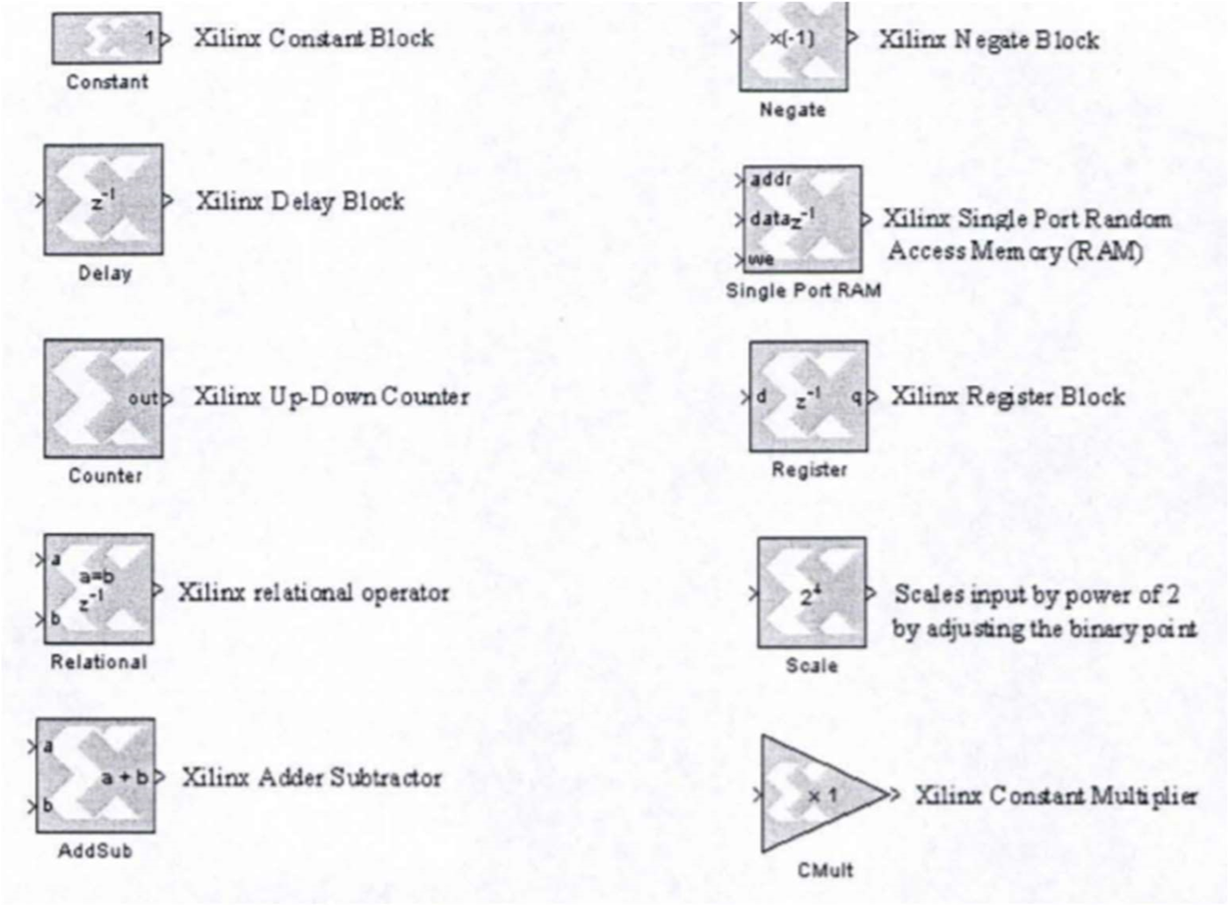

Fig 3.1 basic generator block

3.3. DESIGN 1: THRESHOLD BASED ON PREVIOUSLY DETECTED PEAK

VALUE



The design can be divided into two main sections. The first section is the preprocessing stage. This was where all the filters are implemented. The second section is the peak detection stage where a finite state machine controls the actual detection process. The general outline of the design is shown in figure 3.2 below:

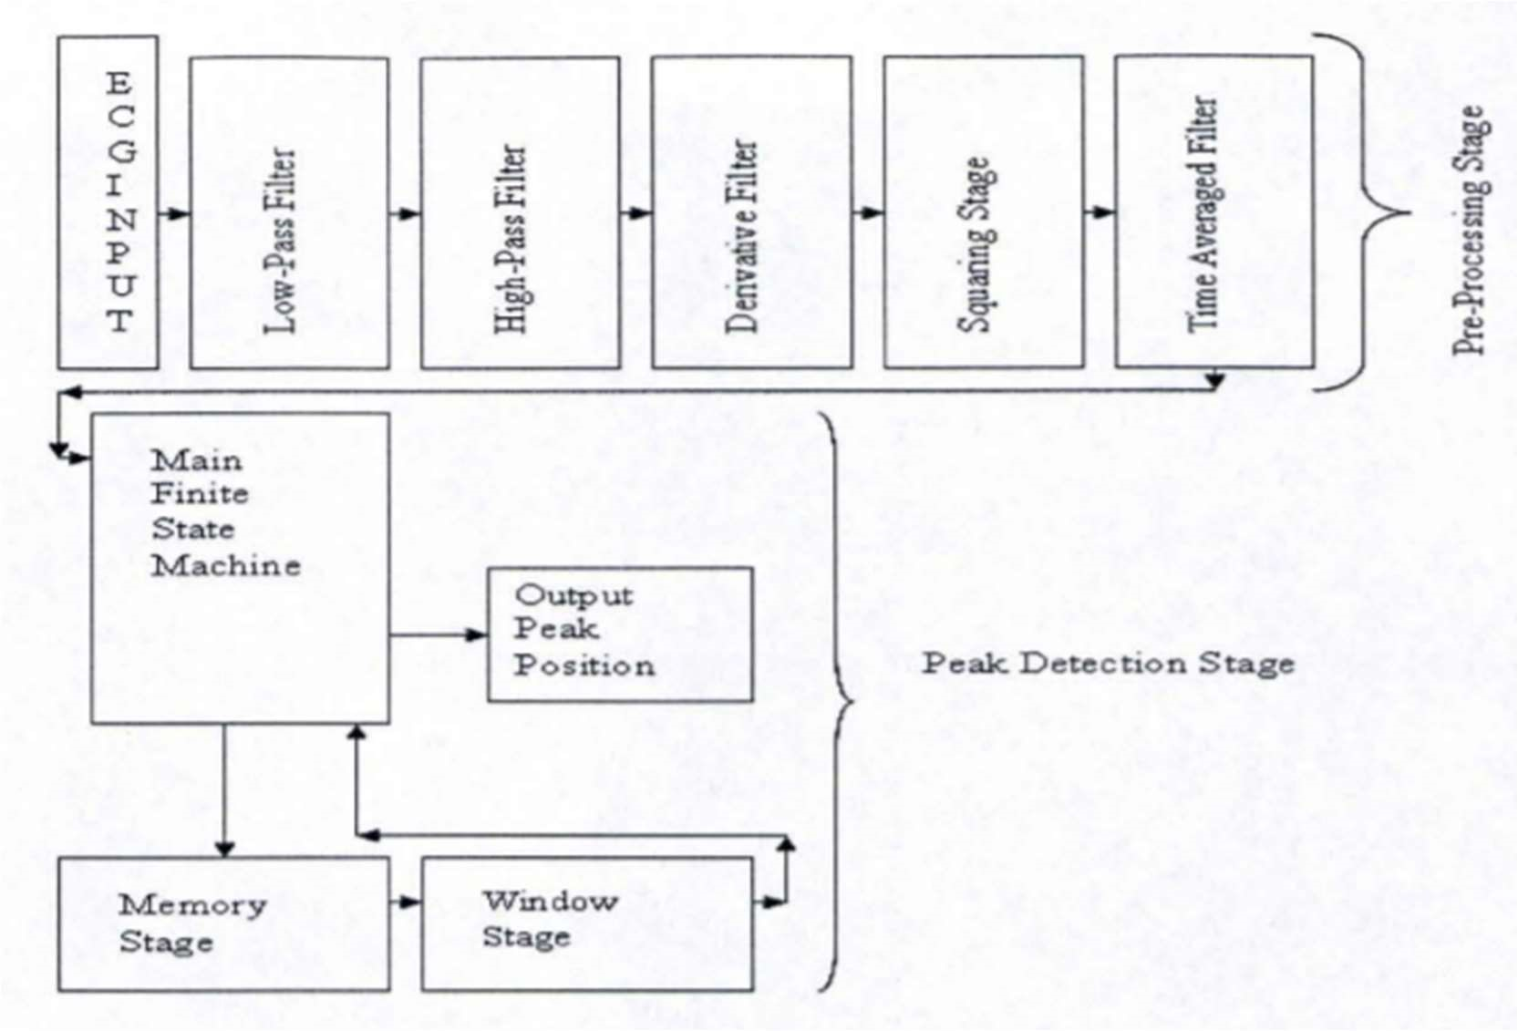

Fig 3.2 General outline of Hardware implementation for design 1

3.4. MEMORY MODULE

This module was implemented using the Block RAM resources available with the Spartan Kit. Based on the way the design was implemented, there was a delay of around 60 samples between the signal at the peak detection stage and the same signal at the band pass stage. Thus, the memory module implemented has a size of 6Ox40 bits.

Please note that the memory is filled from the Oth location all the way down to the 59th location. Hence, the oldest value is stored at the Oth position and the last value is at the 59th position, as shown in the figure 3.3 below:

Fig 3.3 General outline of memory module implementation

The band pass samples are continuously written to the RAM. It was implemented as

a cyclic structure such that the oldest value gets over-written once the RAM is full and

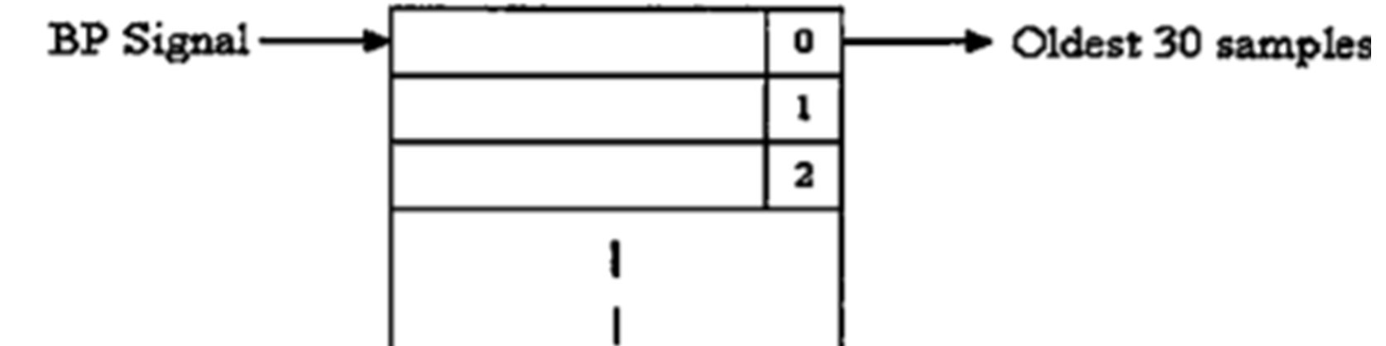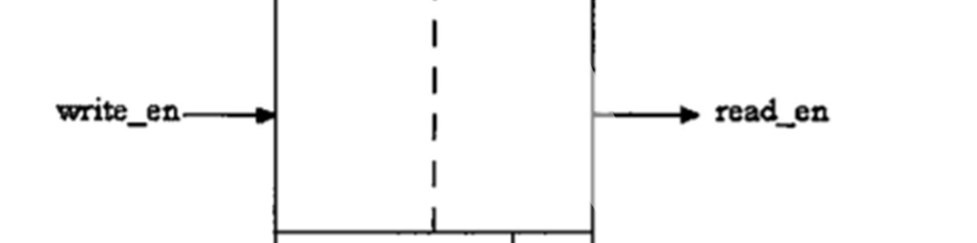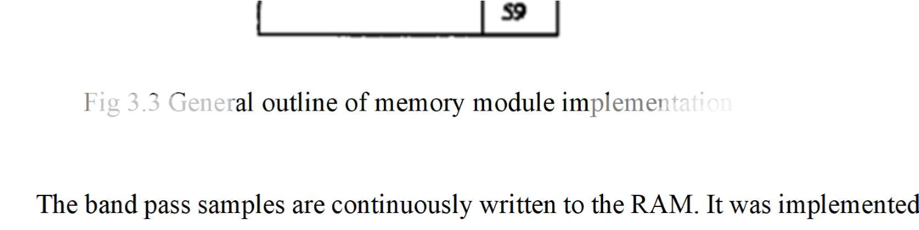

this process is repeated again and again. A signal sent from the Load2 state of the FSM marks the beginning of the reading cycle in the RAM. Once this happens, the oldest 30 sample values are sent to the window module as indicated in figure. This module is very important as it connects the time averaged output to the band pass signal which appeared in the very beginning of the design. A sample output of the memory module is shown in figure It can be seen that only the QRS complex remains and all the other signals are removed completely. This feature of the design could also be used for determining the heart rate or the time between two QRS complexes. Also, it should be noted that the peak of the QRS complex lies within this region.

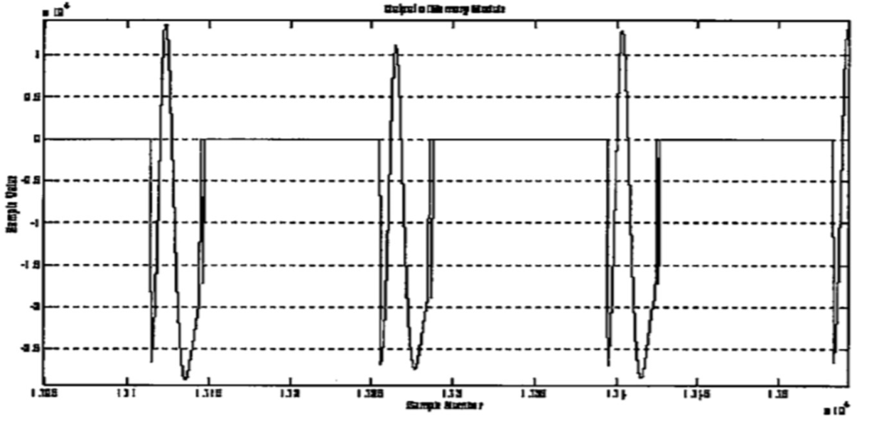

Fig 3.4 output of memory module (QRS complex)

3.5 WINDOW MODULE

The window module gets its input from the memory module discussed previously. Each of the 30 samples input to the window module are compared to each other. Only the position of the largest number is of interest and not value corresponding to this position. Hence, this number (between I and 30) is generated as the output of this block. The output of this module becomes the input to the next state. Apart from the position of the largest sample, another signal indicating that the output is ready is generated and sent to the FSM. This module takes a maximum of 30 clock cycles to execute along with the memory module, as the worst case for the number of comparisons is 30. The window module was implemented in VHDL and the module was imported in the System Generator® environment. The figure 3.5 below shows its internal implementation.

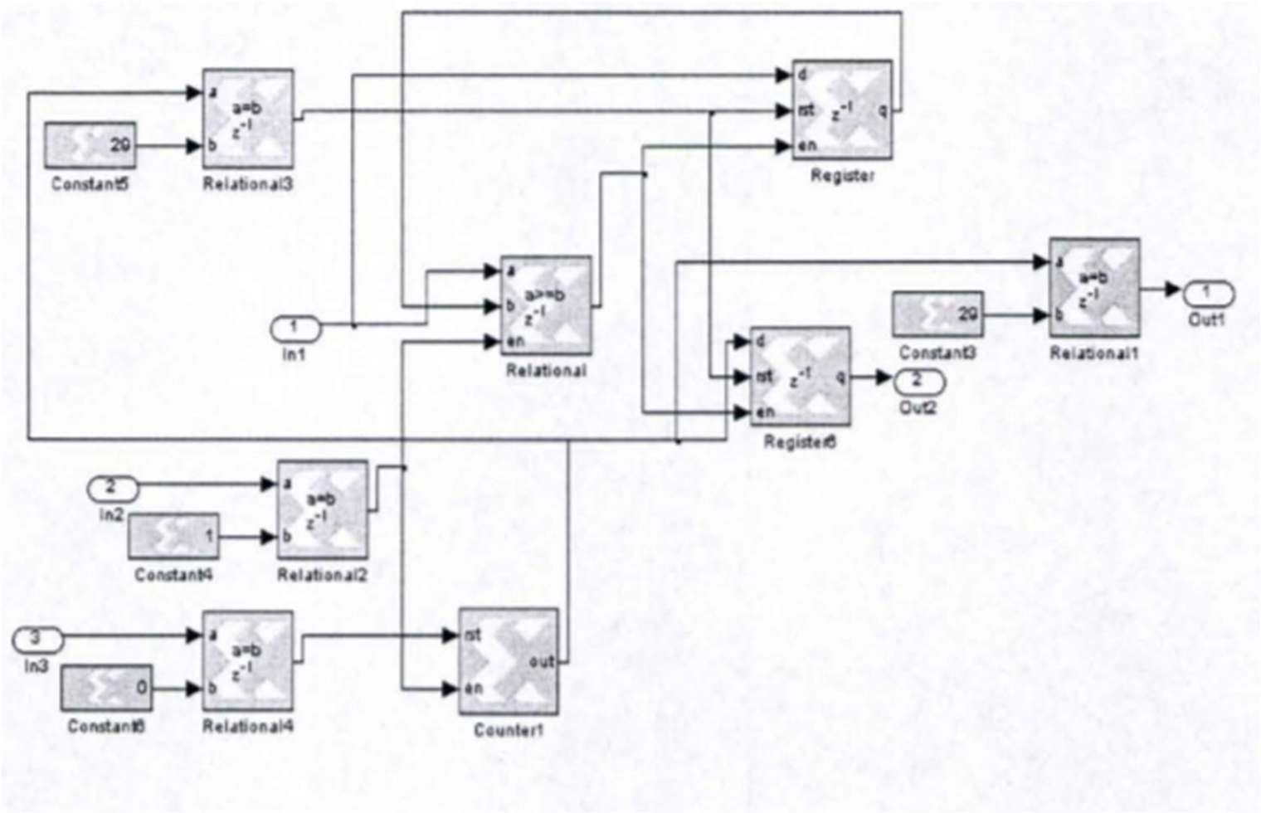

Fig 3.5 Window module implementation in System Generator

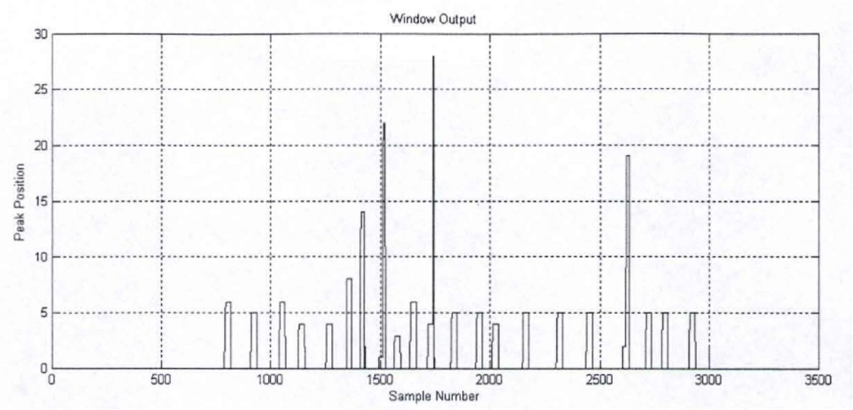

Fig 3.6: Output of window module (Peak position in QRS complex)

It should be noted that the number of samples used in the two modules discussed above depends completely on the way the design is implemented in the System Generator® environment. This section gave a detailed overview of the all the different modules in the design.

CHAPTER 4

SOFTWARE IMPLEMENTATION

ECG signal can be expressed as repetitions of P-QRS-T waves. The basic principle behind the analysis of ECG signal is finding the QRS complex. R peak detection is the 1st and foremost step in finding the QRS complex. Various methods have been implemented in the recent past for R peak detection including Fourier

Transform, Hilbert Transform [1], Difference Operation Method [2], Wavelet Transform [3], Empirical Mode Decomposition [11] etc. We have tried out a few methods in the course of our search for an efficient algorithm for R peak detection.

4.1 USE OF HILBERT TRANSFORM FOR R-PEAK DETECTION

4.1.1 Hilbert Transform

Given a real time function x(t) its Hilbert transform is given by X(t) as

X(t)= H[x(t)]= 1/π 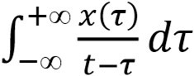 (4.1)

It can be seen from equation 1 that the independent variable is not changed a result of this transformation. So the output F(t) is also a function of t. Moreover F(t) is a linear function of f(t). It is obtained from f(t) by applying convolution with (πt)−1 .

X(t)=(1/πt) *x(t) (4.2)

X(t) and x(t) are related to each other in such a way that they together create a strong analytic signal. The strong analytic signal can been written with a amplitude and phase where the derivative of phase can be identified as the instantaneous frequency. The Fourier transform of the strong analytic signal gives us a one sided spectrum in frequency domain.

The analytic signal is expressed as y(t)= x(t) + j X(t) (4.3) The envelope B(t) of y(t) is B(t)= 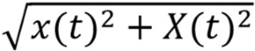 (4.4)

And its instantaneous phase angle in the complex plane can be defined by

Φ(t) = arctan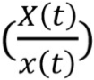 (4.5)

Applying the fourier transform we have

F{x(t)} = 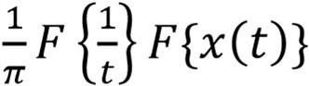

= (4.6)

as

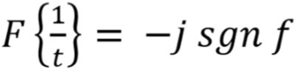

Thus we find that a function and its Hilbert transform are orthogonal. Hilbert transform of the original function x(t) represents its harmonic conjugate.

The use of Hilbert Transform in ECG signal analysis was first described by Bolton and Westphal.

4.1.2 Methodology

The envelope determined using (4) has the same slope and magnitude of the original signal x(t) at or near its maxima. Moreover B(t) is always a positive function as can be seen from (4). Hence, when x(t)=0, the maximum contribution to B(t) is given by the Hilbert transform.

So if we have to find the peaks, i.e. the points where 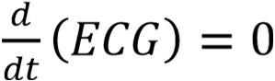 , then indirectly we need to find the maximum contribution to the envelope of the first differential of the ECG. This is the basic principle underlying the use of Hilbert Transform in R-peak detection.

The Algorithm developed by D. Benitez [2] is described below:

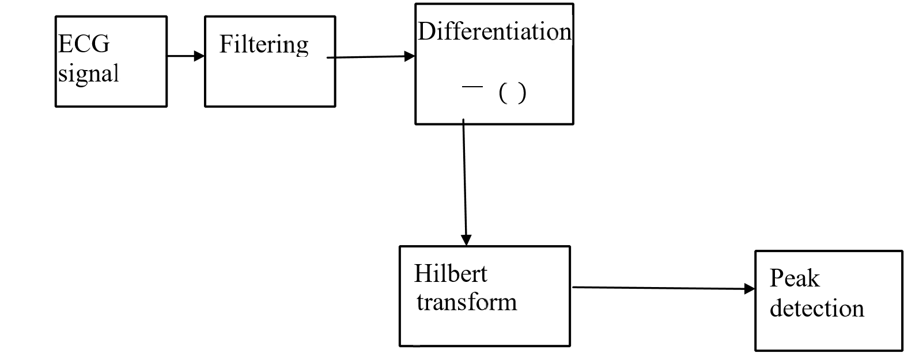

Fig. 4.1 Block diagram of the process of finding R peaks using Hilbert transform

The steps followed can be summarized as follows:

The signal is first filtered to remove noise and enhance the signal.

The filtered signal is then differentiated to get the points of minima or maxima.

The differentiated signal is then transformed using Hilbert Transform and we determine the envelope by using equation (4.4).

Although this method is very crude it comes with some advantages.

The unwanted effects of large peaked T and P waves are minimized. Moreover it has been shown to perform extremely well in the presence of noise [2].

Table. 4.1 Experimental Results for Enhancement Method using EMD

|  |  |  |
| --- | --- | --- |
| Noisy signal SNR (dB) | MIT BIH Record | Enhanced Output  SNR (dB) |
| 5 | 200_1 | 25 |
| 201_1 | 11.35 |
| 202_1 | 11 |
| 210_1 | 7.5 |
| 230_1 | 19.9 |
| 10 | 200_1 | 33.5 |
| 201_1 | 23.56 |
| 202_1 | 20.5 |
| 210_1 | 15.39 |
| 230_1 | 27.89 |
| 15 | 200_1 | 43 |
| 201_1 | 31.34 |
| 202_1 | 28.7 |
| 210_1 | 23.38 |
| 230_1 | 32.11 |
| 20 | 200_1 | 45 |
| 201_1 | 40.95 |
| 202_1 | 45.47 |
| 210_1 | 30.26 |
| 230_1 | 41 |
| 25 | 200_1 | 46.05 |
| 201_1 | 34.1 |
| 202_1 | 51 |
| 210_1 | 37 |
| 230_1 | 42.5 |
| 30 | 200_1 | 49.46 |
| 201_1 | 48.97 |
| 202_1 | 40.9 |
| 210_1 | 43.2 |

|  |
| --- |
| b |

|  |
| --- |
| a |

|  |
| --- |
| c |

Fig. 4.2 (a) clean ECG signal (b) Noisy ECG signal after the addition of White Gaussian Noise (c) Denoised signal after signal enhancement.

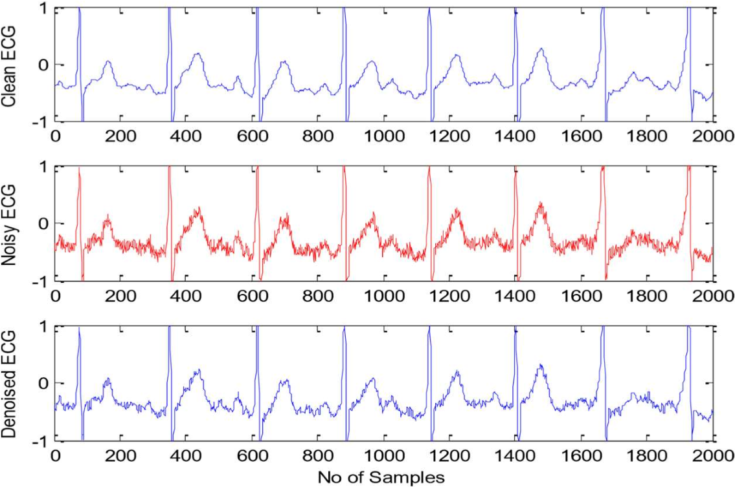

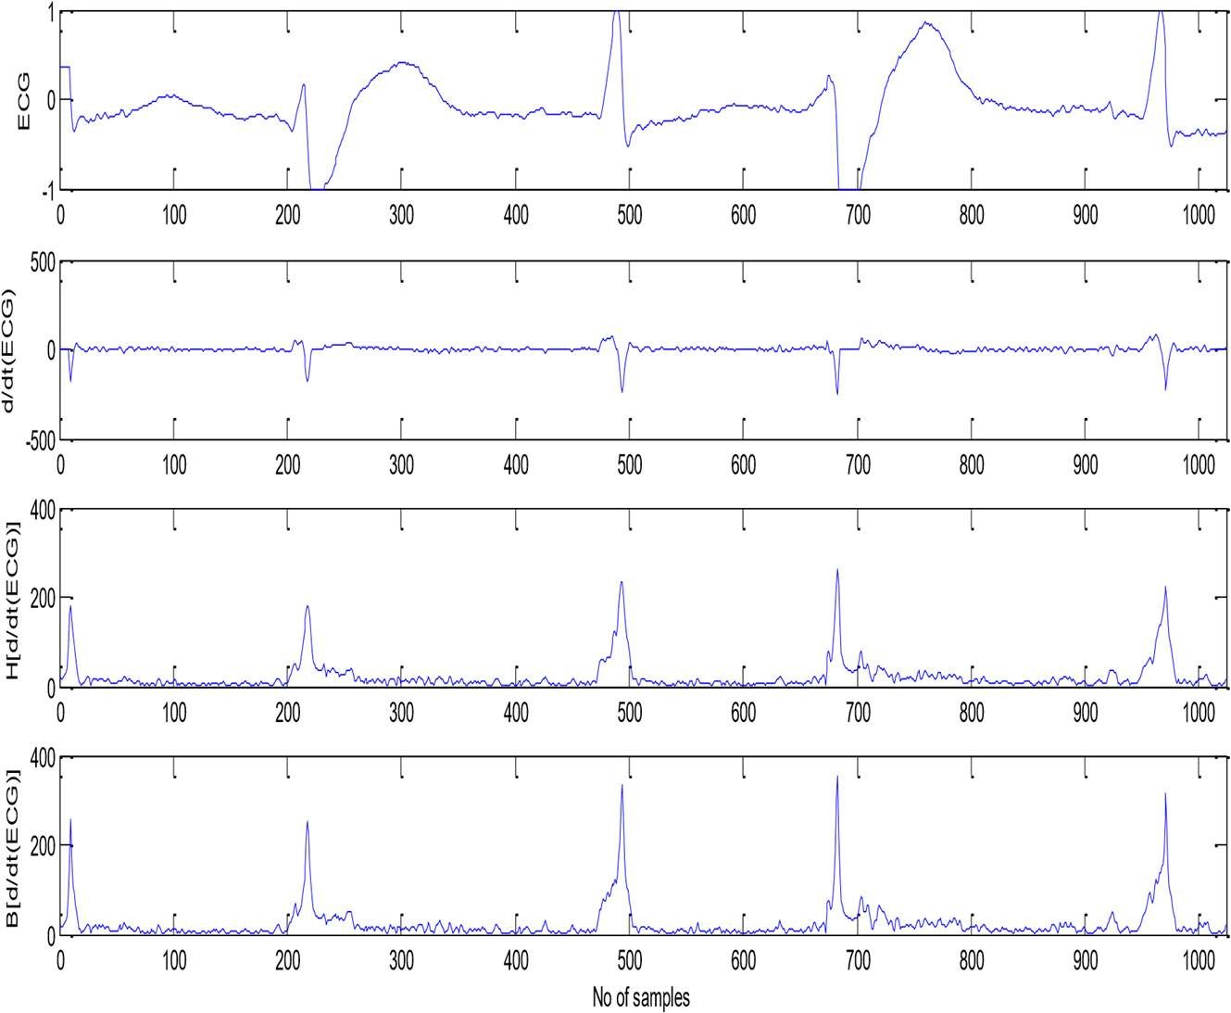

Fig. 4.3 Step by step representation of each stage in the process of using Hilbert

Transform

Table 4.2 indicates the detection error rates and sensitivity. Here FP denotes False Positive i.e. False peak detection and FN denotes False Negative i.e. failure to detect. The total detection error rate is calculated as (FP +FN)/Total no of R peaks *100. The average detection error rate is found to be 0.21%. Efficiency is measured in terms of Sensitivity given by

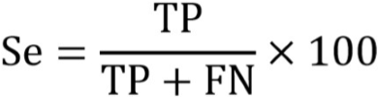

Table 4.2 Experimental Results of using Hilbert Transform for R peak detection

|  |  |  |  |  |  |  |
| --- | --- | --- | --- | --- | --- | --- |
| MIT  BIH  Record | Actual  No of  Beats | FP | FN | FP+FN | Detection Error rate = | Sensitivity  Se= |
| 200 | 2601 | 0 | 0 | 0 | 0 | 100 |
| 201 | 1963 | 2 | 7 | 9 | 0.45 | 99.6 |
| 202 | 2136 | 4 | 4 | 8 | 0.37 | 99.8 |
| 203 | 2982 | 6 | 10 | 16 | 0.53 | 99.6 |
| 205 | 2656 | 0 | 7 | 7 | 0.26 | 99.7 |
| 208 | 2956 | 4 | 5 | 9 | 0.30 | 99.8 |
| 209 | 3004 | 0 | 2 | 2 | 0.06 | 99.9 |
| 210 | 2647 | 2 | 4 | 6 | 0.22 | 99.8 |
| 212 | 2748 | 0 | 4 | 4 | 0.16 | 99.8 |
| 213 | 3251 | 2 | 2 | 4 | 0.12 | 99.9 |
| 215 | 3363 | 5 | 0 | 5 | 0.15 | 100 |
| 217 | 2208 | 0 | 0 | 0 | 0 | 100 |
| 219 | 2154 | 0 | 1 | 1 | 0.05 | 99.9 |
| 220 | 2048 | 2 | 0 | 2 | 0.09 | 100 |
| 221 | 2427 | 1 | 3 | 4 | 0.16 | 99.9 |
| 222 | 2484 | 6 | 15 | 21 | 0.84 | 99.3 |
| 223 | 2605 | 1 | 1 | 1 | 0.04 | 99.9 |
| Average | 2448.7 | 2.06 | 3.82 | 5.82 | 0.23 | 99.8 |

4.2 USE OF DIFFERENCE OPERATION METHOD FOR R PEAK

DETECTION

4.2.1 Difference Operation Method

Difference Operation is a simple and fast method for detecting QRS complexes [1]. DOM includes two stages:

1st stage is to find the R peak by applying difference operation to the ECG signal. 2nd stage looks for points Q and S to find the QRS complex.

The Difference Operation method doesn’t involve any complex mathematical calculation such as cross-correlation, Fourier transform etc. It essentially involves finding the difference signal or the derivative. Thus it uses basic calculus for finding the peak points.

The method of Difference operation is as follows:

▪ Obtain the difference signal of a given signal x(t) as d(t)= x(t)-x(t-1) ▪ The difference signal is passed through a low pass filter to obtain df(t) ▪ Threshold is used for finding the required peak points.

4.2.2 Methodology

The algorithm for the difference operation method [1] is described below:

The difference operation is first implemented according to the following steps:

* Download the original ECG signal x
* Obtain the difference signal xd given as xd(n)=x(n)-x(n-1)
* Pass the difference signal through a low pass filter to obtain xdf • xdf is then put through thresholding to obtain xdf 1

R peaks are then detected by following the steps as given below:

* Separate xdf1 into two kinds of signals : positive and negative parts
* Select the correct extreme value points
* The position of maximum positive value is point R in the interval

The process followed for Q and S detection is:

* Consider 20 points before and after R-peak .The position of minimum value in front of R is Q1 and after R is S1.
* Consider 80 points before and after R peak. The position of minimum value in front of R is Q2 and after R is S2.
* If pos(Q2)=pos(Q1) then Q=Q1 If Vq2<Vq1 then Q=Q2

If Vq2>Vq1 then Q=Q1

The method may not show outstanding efficiency but has its advantages. It is very simple and fast and doesn’t involve complex equations as in case of Fourier methods. It is useful in cardiac arrhythmia diagnosis method [14].

On implementing DOM method as proposed by Yun-Chi Yeh [1], we found the method to be simple, efficient and having less computational time. The efficiency was measured in terms of detection error rate i.e. it is a measure of the number of failures.

Simulation was carried out in MATLAB environment. The signals used are from the MIT-BIH database.

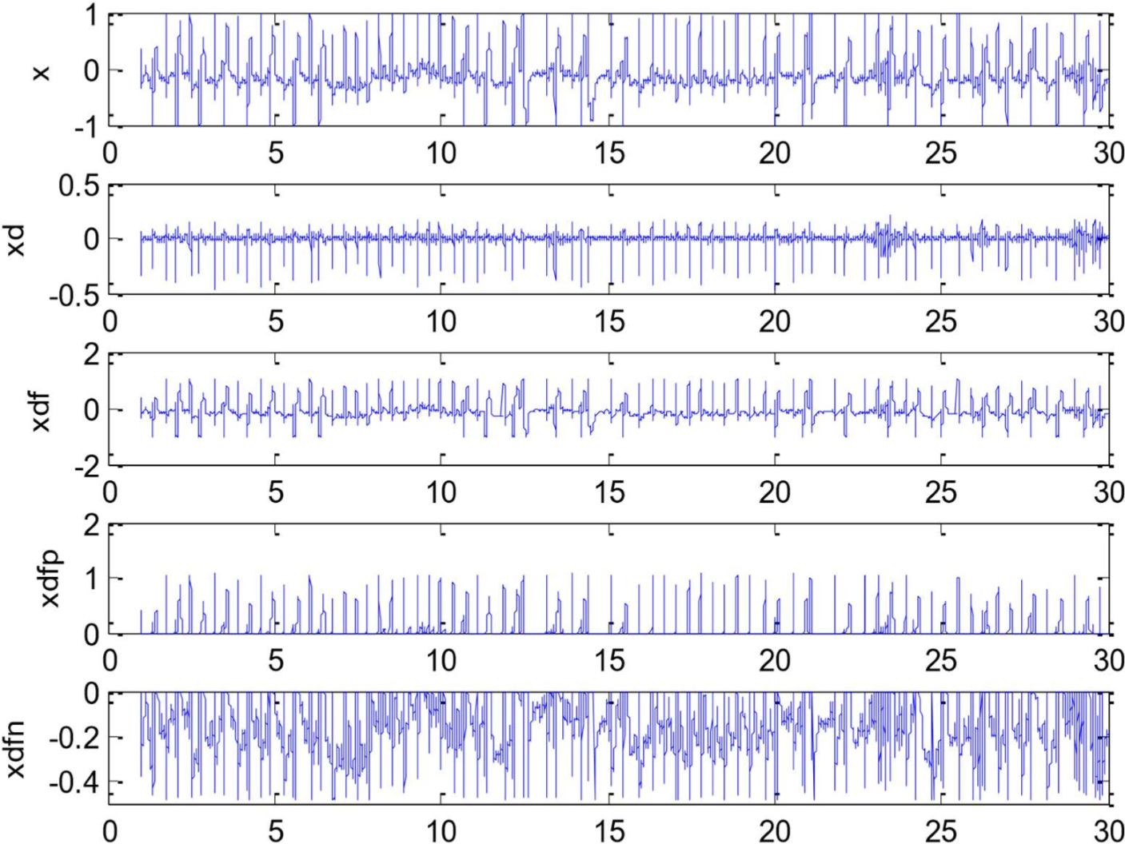

Fig. 4.4 Step by step representation of the various stages in the DOM method

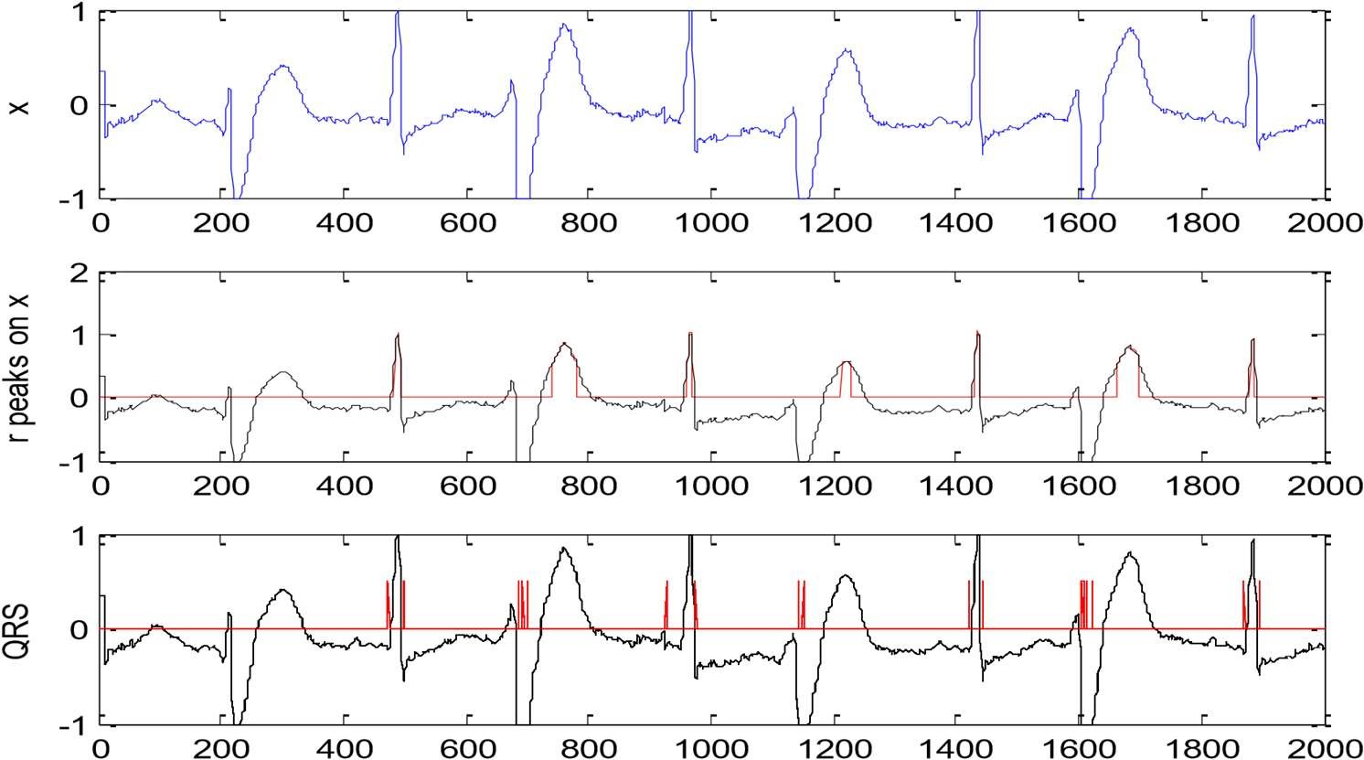

Fig 4.5 R peak and QRS detection using DOM approach: Red lines denote R peaks and QRS complex.

Table 4.3 Experimental Results for the use of DOM approach in R peak detection

|  |  |  |  |  |  |  |
| --- | --- | --- | --- | --- | --- | --- |
| MIT  BIH  Record | Actual  No of  Beats | FP | FN | FP+FN | Detection Error rate = | Sensitivity  Se= |
| 200 | 2601 | 0 | 0 | 0 | 0 | 100 |
| 201 | 1963 | 3 | 0 | 3 | 0.15 | 100 |
| 202 | 2136 | 8 | 0 | 8 | 0.37 | 100 |
| 203 | 2982 | 6 | 1 | 7 | 0.23 | 99.9 |
| 205 | 2656 | 10 | 0 | 10 | 0.38 | 100 |
| 208 | 2956 | 8 | 0 | 8 | 0.27 | 100 |
| 209 | 3004 | 0 | 2 | 2 | 0.06 | 99.9 |
| 210 | 2647 | 10 | 0 | 10 | 0.38 | 100 |
| 212 | 2748 | 1 | 1 | 2 | 0.07 | 99.9 |
| 213 | 3251 | 7 | 2 | 9 | 0.27 | 99.9 |
| 215 | 3363 | 0 | 10 | 10 | 0.29 | 99.7 |
| 217 | 2208 | 0 | 0 | 0 | 0 | 100 |
| 219 | 2154 | 1 | 0 | 1 | 0.05 | 100 |
| 220 | 2048 | 2 | 0 | 2 | 0.09 | 100 |
| 221 | 2427 | 4 | 6 | 10 | 0.41 | 99.7 |
| 222 | 2484 | 6 | 0 | 6 | 0.24 | 100 |
| 223 | 2605 | 1 | 0 | 1 | 0.04 | 100 |
| Average | 2448.7 | 3.9 | 1.29 | 5.23 | 0.21 | 99.94 |

4.3 USE OF CONTINUOUS WAVELET TRANSFORM IN R PEAK

DETECTION

4.3.1 Wavelet Transform

Wavelets are a powerful tool for the representation and analysis of ECG signal. They have been implemented for the analysis of physiological waveforms like ECG, Phonocardiogram etc. [15] [3] [13] [17]. This is because wavelet has finite duration as compared to Fourier methods based on sinusoids of infinite duration.

Wavelet Transform involves the decomposition of signal into various components. They provide both time and frequency view. Unlike Fourier transform, they are very efficient for non-stationary signals like ECG.

The Fourier Transform is a widely used tool for many scientific purposes but it is well suited for stationary signals. Gabor introduced a local Fourier analysis. He used the concept of a sliding window. This method, however, gives results when the coherence time is independent of frequency. Morlet introduced Wavelet Transform to have a coherence time proportional to the period. In Wavelet Transform, a fully scalable modulated window is used which solves the signalcutting problem. The window is shifted along the signal. Spectrum is calculated for every position. This process is repeated by varying the length of the window. So we have a collection of representations, hence the name multi-resolution analysis.

4.3.2 Continuous Wavelet Transform

Wavelet transforms are applied to decompose the signal into a set of coefficients that describe the signal frequency content at given times. The continuous wavelet transform of the signal, x(t), is defined as [3]:

 (4.7)

Here Ψ(t) is the analyzing wavelet function is the dilation parameter and b is the location parameter of the wavelet.

Actually the wavelets are generated from a single basic wavelet Ψ(t), the so called mother wavelet, by scaling and translation.

𝜑 𝑠, 𝜏 (4.8)

Due to the scaling and translation, Wavelet Transform is localized in both time and frequency.

Several Mother Wavelets like Mexican-hat and Morlet have been used in ECG signal analysis. The mother wavelet has a lot of significance for the efficiency of the process. In this paper we have used Haar Wavelet as the mother wavelet. We have gone for Haar wavelet because the oscillatory nature of other mother wavelets results in several ridges for each ECG component, while only one pair of ridges is generated via the Haar wavelet due to its configuration.

The Haar wavelet's mother wavelet function Ψ(t) as shown in Fig can be described as

Ψ(t) = 1 0 ≤ t < 1 /2

=-1 1/ 2 ≤ t < 1

= 0 otherwise

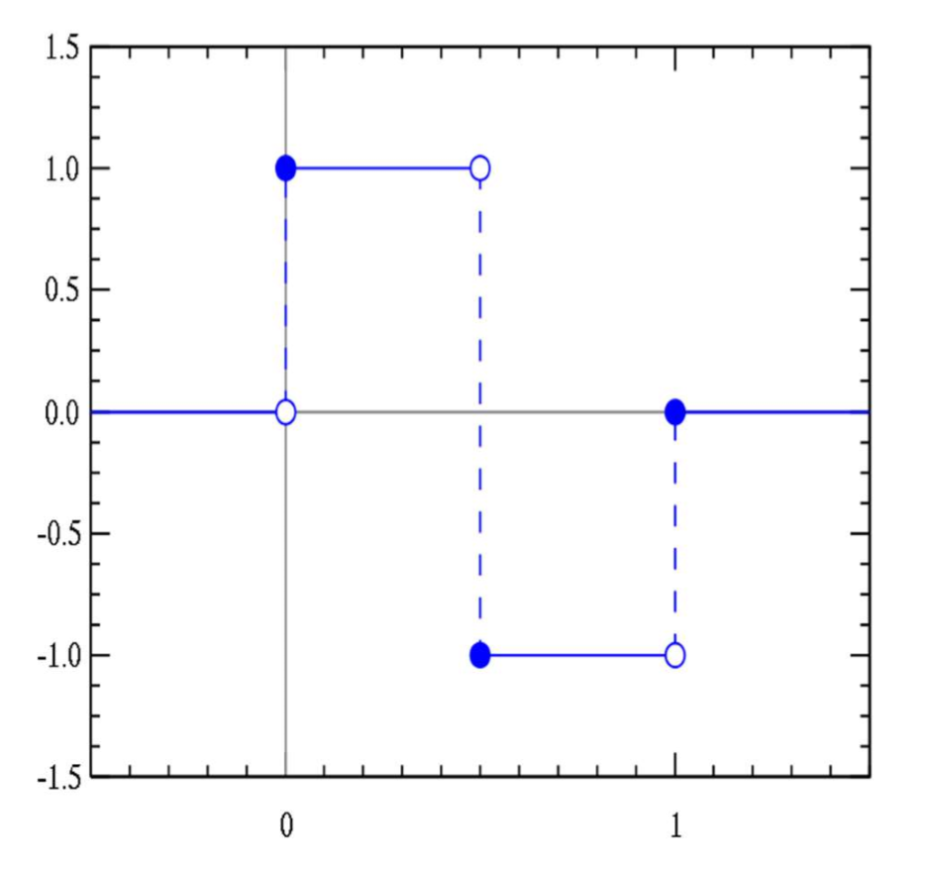

Fig. 4.6 Haar Mother wavelet

We have chosen CWT over DWT because unlike DWT there is no dyadic frequency jump in Continuous wavelet transform [3]. Also high resolution in timefrequency domain is achieved.

4.3.3 Methodology

The basic principle involved here is using a threshold detector [3].

After the enhancement of the ECG signal, it is transformed using Continuous Wavelet Transform using equation (2). The mother wavelet used here is the Haar Mother wavelet. It is preferred here because the oscillatory nature of other mother wavelets results in several ridges for each ECG component, while only one pair of ridges is generated via the Haar wavelet due to its configuration.

The second step involves the use of a Threshold based detector. Positive maximum peaks larger than a threshold are selected. The main threshold is chosen as a fraction of root mean square of the signal. We have chosen this to be around

two times the root mean square of the signal after carrying out a series of experiments.

For further identification of Q and S peaks we use search intervals. Other positive and negative peaks are searched about the R peaks. The positive maximum peak to the left of R peak denotes Q and the negative minimum peak to the right of R peak denotes S. The search interval is taken as 2.5 times of the scale to the left of R peak and 2 times to the right of it. To avoid misdetection of P and T waves each interval is checked for interference.

The CWT method is found to have a good sensitivity. The average detection error rate is very low making this method highly lucrative. Moreover this method is much more evolved than others. The best feature of this method is that it is suitable for non-stationary signals like ECG. Comparing the detection error rates and sensitivity of the different methods in Table find that CWT is a better choice for R peak detection.

Table 4.4: Performance comparison of the methods of R peak detection

|  |  |  |
| --- | --- | --- |
| Method | Detection error rate | Sensitivity |
| Hilbert Transform | 0.23 | 99.8 |
| Difference Operation  Method | 0.21 | 99.94 |
| Continuous Wavelet  Transform  (Proposed Method) | 0.01 | 99.84 |

We have used MIT-BIH database in MATLAB environment to validate the efficiency of the method. After the process of enhancement, we have implemented R peak detection using CWT. Table indicates the detection error rates and sensitivity. The detection error rate calculated for this method is 0.01% while the sensitivity is found to be 99.84%.

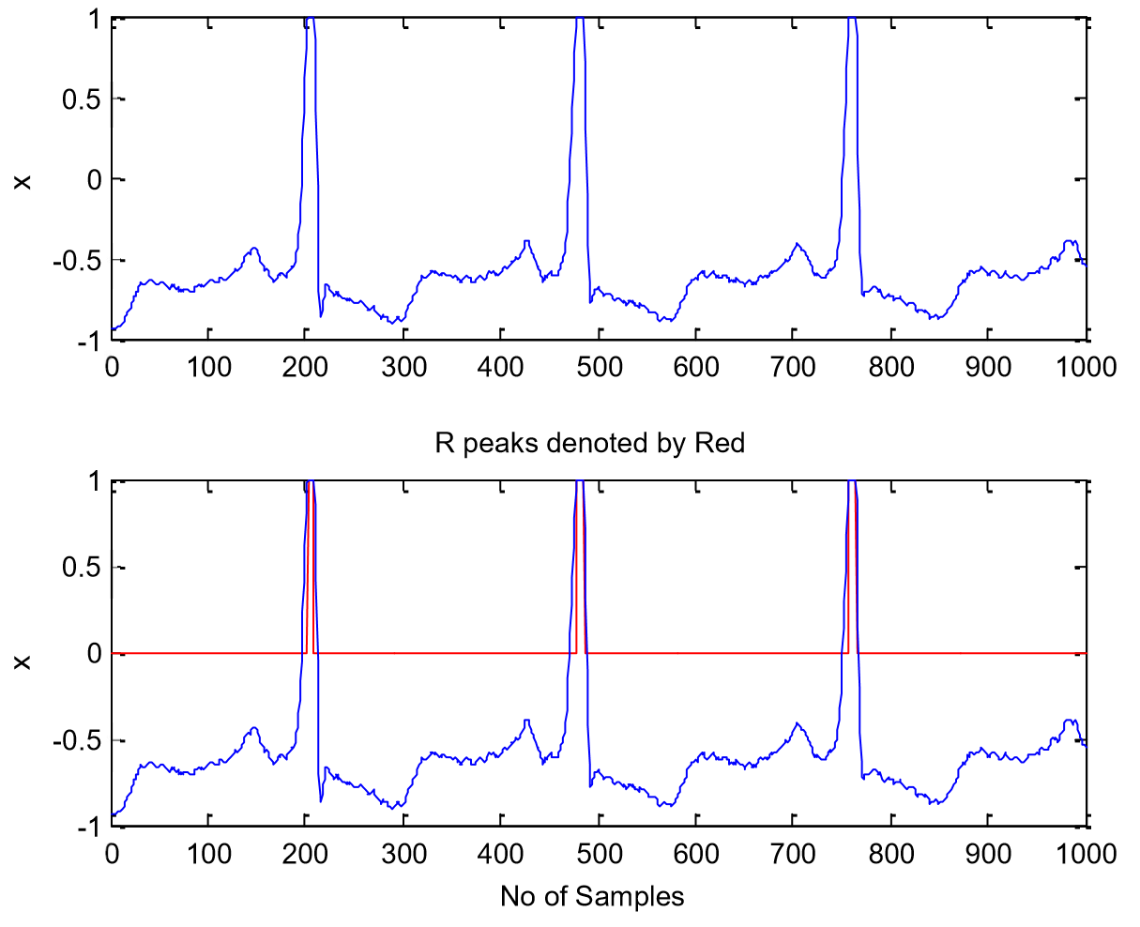

Fig. 4.7 R peak detection using Continuous Wavelet Transform

Table 4.5 Experimental results of the R peak detection using CWT

|  |  |  |  |  |  |  |
| --- | --- | --- | --- | --- | --- | --- |
| MIT  BIH  Record | Actual  No of  Beats | FP | FN | FP+FN | Detection Error rate = | Sensitivity  Se= |
| 200 | 2601 | 0 | 1 | 1 | 0.04 | 99.9 |
| 201 | 1963 | 2 | 12 | 14 | 0.71 | 99.3 |
| 202 | 2136 | 8 | 0 | 8 | 0.37 | 100 |
| 203 | 2982 | 2 | 30 | 32 | 1.07 | 98.9 |
| 205 | 2656 | 0 | 1 | 1 | 0.05 | 99.9 |
| 208 | 2956 | 0 | 5 | 5 | 0.16 | 99.8 |
| 209 | 3004 | 0 | 0 | 0 | 0 | 100 |
| 210 | 2647 | 0 | 4 | 4 | 0.15 | 99.8 |
| 212 | 2748 | 0 | 4 | 4 | 0.16 | 99.8 |
| 213 | 3251 | 0 | 2 | 2 | 0.06 | 99.9 |
| 215 | 3363 | 6 | 0 | 6 | 0.18 | 100 |
| 217 | 2208 | 0 | 0 | 0 | 0 | 100 |
| 219 | 2154 | 0 | 0 | 0 | 0 | 100 |
| 220 | 2048 | 0 | 0 | 0 | 0 | 100 |
| 221 | 2427 | 0 | 4 | 4 | 0.16 | 99.8 |
| 222 | 2484 | 0 | 20 | 20 | 0.81 | 99.2 |
| 223 | 2605 | 0 | 0 | 0 | 0 | 100 |
| Average | 2448.7 | 1.05 | 4.88 | 5.94 | 0.01 | 99.84 |

CHAPTER 5

RESULTS

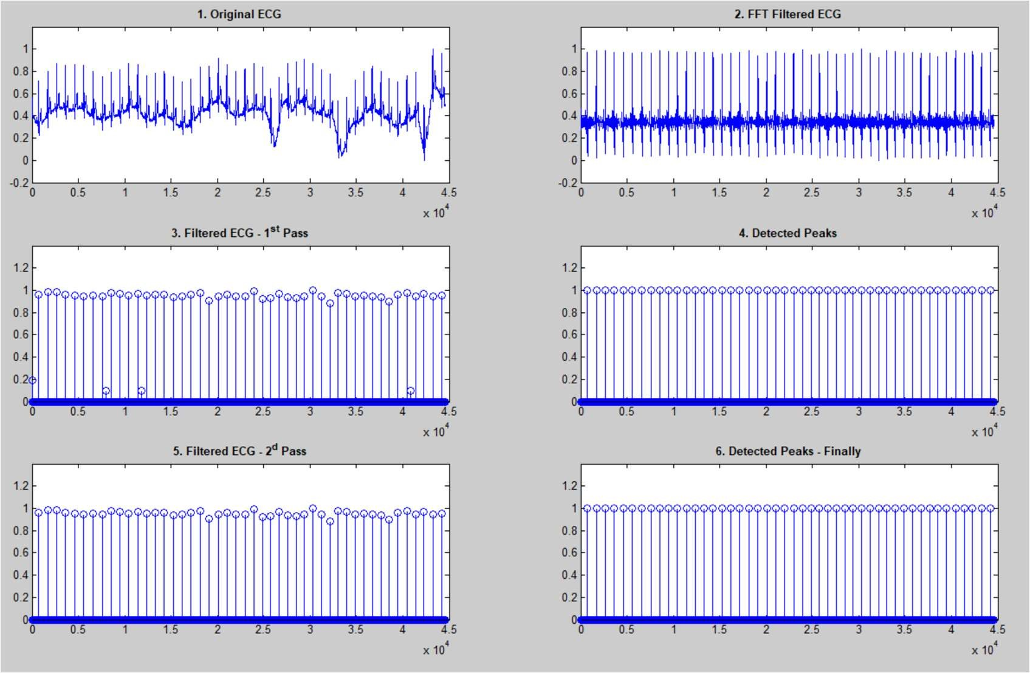

Fig: 5.1 output of Original ECG signal input and Detected output

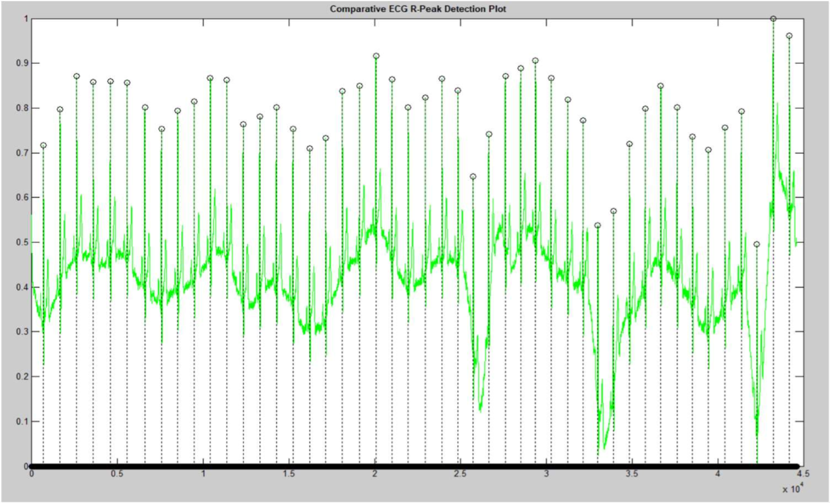

Fig: 5.2 Comparative ECG R-Peak Detection Plot

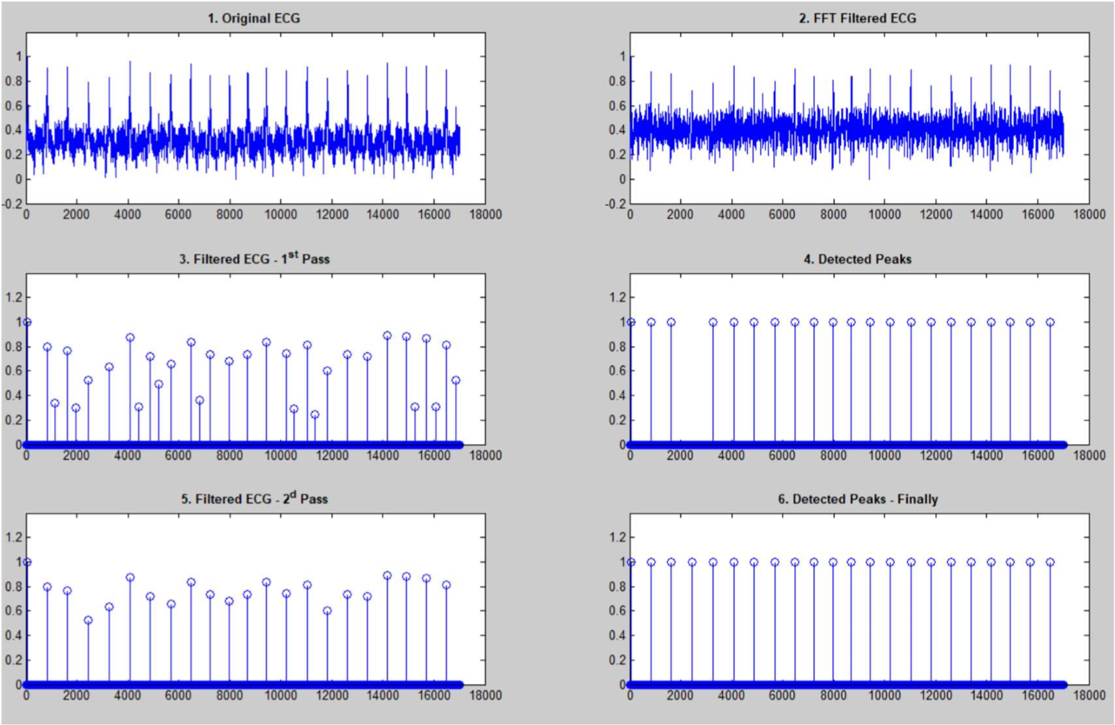

fig: 5.3 Various stages undergone for Detection and removal of noise

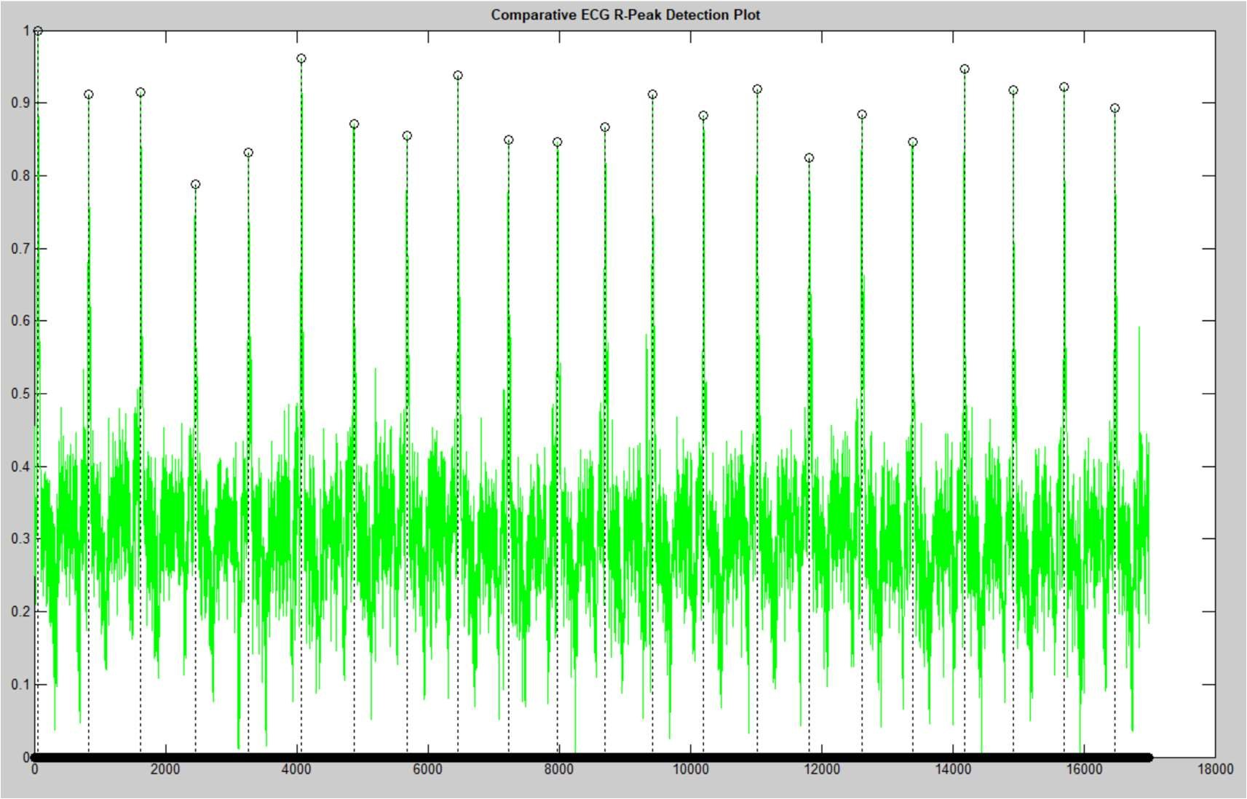

Fig:5.4 Comparative ECG R-Peak Detection Plot

CHAPTER 6

CONCLUSION

The objective of this project was to develop a method for efficient analysis of ECG signal.

In this method, a proposed novel method of enhancement of ECG signal using Empirical Mode Decomposition. Deviating from other approaches of using EMD, It is Recommended to use the low-pass filters for efficient noise removal.

A number of earlier proposed methods for R peak detection including Hilbert

Transform, Difference Operation Method and Continuous Wavelet Transform. The efficiency in case of CWT is better as compared to other methods. The average detection error rate for CWT is 0.01% as compared to 0.23% of Hilbert Transform Method and 0.21% of DOM method. The sensitivity of DOM (99.94%) is better than CWT (99.84%), but the low detection error rates compensates for this.

Thus the method of signal enhancement and R peak detection using Empirical Mode Decomposition method and Continuous Wavelet Transform is a novel, efficient method having less computation time, hence best suited for analysis of ECG signal for clinical purposes.

CHAPTER 7

FUTURE ENHANCEMENT

* Empirical Mode Decomposition and Wavelet Transform are both very recent techniques. Hence a lot of research needs to be done on the properties still simpler methods for ECG signal Analysis.
* Feature extraction is yet another field in ECG signal Analysis is untouched. But it is very important for classification of Arrthymia. Hence future work will be dedicated to feature extraction and classification.
* The process of enhancement can be modified using more evolved techniques. Research needs to be done for finding more efficient methods for signal enhancement.

CHAPTER 8

REFERENCES

1. Yun-Chi Yeh, Wen-June Wang, “QRS complex detection for ECG signal: The Difference Operation Method”, Computer Methods and Programs in Biomedicine 9 I(2008) 245-254
2. D.Benitez, “The use of Hilbert Transform in ECG Signal Analysis”, Comput. Biol .Med. 31 (2001) 399-406
3. A.Ghaffari, H.Golabayani, M.Ghasemi, “A new mathematical based QRS detector using continuous wavelet transform”, Computers and Electrical Engineering 34(2008) 81-91
4. Yan Lu, Jingyu Yan, and Yeung Yam, “Model Based ECG denoising using empirical mode decomposition,” IEEE International Conference on

Bioinformatics and Biomedicine, pp. 191-196, 2009.

1. Guodong Tang and Aina Qin, “ECG Denoising based on Empirical Mode

Decomposition,” 9th International Conference for Young Computer Scientists, pp. 903906

1. N. E. Huang, Z. Shen, S. R. Long, M. C. Wu, H. H. Shih, Q. Zheng, N.-C. Yen, C. C. Tung, and H. H. Liu, “The empirical mode decomposition and the Hilbert spectrum for nonlinear and nonstationary time series analysis,” Proc. Roy. Soc.

Lond., vol. A 454, pp.

903–995, 1998.

1. A.Barros, A.Mansour, and N.Ohnishi, “Removing Artifacts from ECG signals using independent components analysis”, Neuro-computing, vol.22, pp-173-186, 1998
2. G.D. Clifford and L. Tarassenko, “One-pass training of optimal architecture autoassociative neural network for detecting ectopic beats,” Electron Lett., vol. 37, no. 18, pp. 1126-1127, Aug. 2001
3. P.M. Agante and J.P.M de Sa, “ECG noise filtering using wavelets using soft thresholding methods”, in Proc. Comput. Cardiology 1999, pp. 535-542
4. F.A.Davis, “ECG_NOTES,” 2005
5. Jing- tian Tang,Xiao –li Yang, “The Algorithm of R peak detection in ECG based on empirical Mode Decomposition”, IEEE, 4th International Conference on Natural Computation.
6. Hualao Ling,Qiu-Hua Lin and J.D.X.Chen, “Application of the Empirical Mode decomposition to the analysis of Esophageal Reflux Disease”, IEEE transactions on Biomedical Engineering, Vol.52,No.10 (2005)
7. Conor McCooey, Dinesh Kant Kumar and Irena Cosic, ”Decomposition of Evoked Potentials using Peak Detection and the Discrete Wavelet Transform”, proceedings of 2005 IEEE, pp 2071-2074 (2005) .
8. Yun-Chi Yeh, Wen-Jun Wang, Che Wun Chiou,” Cardiac arrhythmia diagnosis method using linear discriminant analysis on ECG signals”, Measurement 42(2009) 778789.
9. Sreeraman Rajan, R. Doraiswami, M. Stevenson and R.Waltrous,” Wavelet based bank of correlators approach for phonocardiogram signal classification”, IEEE, pp. 77-80 (1998).
10. Nugent, C.D, Webb, J.A.C, Black, N.D., Wright, G.T.H.and M. McIntyre; “An intelligent framework for the classification of the 12-lead ECG”, Artificial Intelligence in Medicine 16 (1999) 205–222 .

1. Szi-Wen Chena, Hsiao-Chen Chena and Hsiao-Lung Chanb ; “A real-time QRS detection method based on moving-averaging incorporating with wavelet denoising”; Computer methods and programs in biomedicine 82 (2006) 187–195.

1. I.K. Daskalov and I.I. Christov, “Electrocardiogram signal preprocessing for automatic detection of QRS boundaries” Medical Engineering & Physics, vol. 21, pp. 37–44, 1999.
2. S.S. Mehta and N.S. Lingayat, “SVM-based algorithm for recognition of QRS complexes in electrocardiogram”, IRBM 29 (2008) 310–317.

1. S.S. Mehta, D.A. Shete, N.S. Lingayat and V.S. Chouhan , “K-means algorithm for the detection and delineation of QRS-complexes in Electrocardiogram”, IRBM 47 (2009).

APPENDIX

ECGDEMO ECG PROCESSING DEMONSTRATION - R-PEAKS DETECTION

%

% This file is a part of a package that contains 5 files:

% 1. ecgdemo.m - (this file) main script file;

% 2. ecgdemowinmax.m - window filter script file;

% 3. ecgdemodata1.mat - first ecg data sample; % 4. ecgdemodata2.mat - second ecg data sample; % 5. readme.txt - description.

% To run the demo put

%

% ecgdemo.m;

% ecgdemowinmax.m;

% ecgdemodata1.mat;

% ecgdemodata2.mat

%

% in MatLab's "work" directory, run MatLab and type in

%

% >> ecgdemo

% We are processing two data samples to demonstrate two different situations for demo = 1:2:3 % Clear our variables

clear ecg samplingrate corrected filtered1 peaks1 filtered2 peaks2 fresult

% Load data sample

switch(demo)

case 1,

plotname = 'Sample 1'; load ecgdemodata1; case 3,

plotname = 'Sample 2'; load ecgdemodata2;

end

% Remove lower frequencies

fresult=fft(ecg); fresult(1 : round(length(fresult)*5/samplingrate))=0; fresult(end - round(length(fresult)*5/samplingrate) : end)=0; corrected=real(ifft(fresult));

% Filter - first pass

WinSize = floor(samplingrate * 571 / 1000); if rem(WinSize,2)==0

WinSize = WinSize+1; end filtered1=ecgdemowinmax(corrected, WinSize);

% Scale ecg peaks1=filtered1/(max(filtered1)/7); % Filter by threshold filter for data = 1:1:length(peaks1) if peaks1(data) < 4 peaks1(data) = 0; else

peaks1(data)=1;

end end

positions=find(peaks1); distance=positions(2)-positions(1); for data=1:1:length(positions)-1 if positions(data+1)-positions(data)<distance distance=positions(data+1)-positions(data); end end

% Optimize filter window size QRdistance=floor(0.04*samplingrate); if rem(QRdistance,2)==0

QRdistance=QRdistance+1; end

WinSize=2*distance-QRdistance;

% Filter - second pass

filtered2=ecgdemowinmax(corrected, WinSize); peaks2=filtered2; for data=1:1:length(peaks2) if peaks2(data)<4 peaks2(data)=0; else

peaks2(data)=1;

end end

% Create figure - stages of processing

figure(demo); set(demo, 'Name', strcat(plotname, ' - Processing Stages'));

% Original input ECG data

subplot(3, 2, 1); plot((ecg-min(ecg))/(max(ecg)-min(ecg)));

title('\bf1. Original ECG'); ylim([-0.2 1.2]);

% ECG with removed low-frequency component

subplot(3, 2, 2); plot((corrected-min(corrected))/(max(corrected)-min(corrected))); title('\bf2. FFT Filtered ECG'); ylim([-0.2 1.2]);

% Filtered ECG (1-st pass) - filter has default window size

subplot(3, 2, 3); stem((filtered1-min(filtered1))/(max(filtered1)-min(filtered1))); title('\bf3. Filtered ECG - 1^{st} Pass'); ylim([0 1.4]);

% Detected peaks in filtered ECG subplot(3, 2, 4); stem(peaks1);

title('\bf4. Detected Peaks'); ylim([0 1.4]);

% Filtered ECG (2-d pass) - now filter has optimized window size subplot(3, 2, 5); stem((filtered2-min(filtered2))/(max(filtered2)-min(filtered2))); title('\bf5. Filtered ECG - 2^d Pass'); ylim([0 1.4]);

% Detected peaks - final result subplot(3, 2, 6); stem(peaks2); title('\bf6. Detected Peaks - Finally'); ylim([0 1.4]);

% Create figure - result

figure(demo+1); set(demo+1, 'Name', strcat(plotname, ' - Result'));

% Plotting ECG in green

plot((ecg-min(ecg))/(max(ecg)-min(ecg)), '-g'); title('\bf Comparative ECG R-Peak Detection Plot');

% Show peaks in the same picture

hold on

% Stemming peaks in dashed black stem(peaks2'.*((ecg-min(ecg))/(max(ecg)-min(ecg)))', ':k');

% Hold off the figure hold off end

.